

MLIB Yield Curve
Settings & State Variables

Version | Date | Author
1.0 | 01 Nov 2019 | Nicholas Burgess
Contents
Yield Curve State Variables 3
Yield Curve Key Parameter Settings 3
OIS Curve Settings 3
STD Swap Curve Settings 4
Tenor- & Xccy Basis Curve Settings 6
FX Forward Curve Settings 7

Yield Curve State Variables
Using the below definition of the discount factor (DF), where z denotes the corresponding zero rate and t < T,
$DF\left(t, T\right)= exp⁡(-z*\left(T-t\right))$ (32)
yield curves are calibrated and interpolated with respect to the following state variables

Table 1: Yield Curve State Variables
Curve Type Instruments State Variable
OIS Curve All Zero Rates
Swap Curve Futures / FRAs Log of Discount Factors
Swap Curve Swap Log of Discount Factors
Tenor & Xccy Basis Curves FX Forwards Discount Factors
Tenor & Xccy Basis Curves Basis Swaps Log of Discount Factors
FX Forward Constant Curve N/A Implied from Dependency Curves
Cheapest-to-Deliver Curve N/A Implied from Dependency Curves

Table 2: Global Yield Curve State Variable(s)
Curve Type Instruments State Variable
Global Curve All Log of Discount Factors

Yield Curve Key Parameter Settings
We highlight key parameter settings used in yield curve construction for the OIS, STD Swap, Tenor Basis, Xccy Basis curves respectively.

OIS Curve Settings
CompoundingMethod ARITHMETIC, GEOMETRIC, SIMPLE, FLAT
This parameter specifies the OIS coupon compounding methodology, which includes arithmetic averaging, geometric averaging, simple and flat.

LongTerm.GenerateMethod LOBASIS
This field is used to specify if Libor-OIS spread instruments are to be specified and included as calibration instruments. Simply enter LOBASIS to include and leave blank to not use Libor-OIS spread instruments.
LongTermConvention Example: 3Y
Here we specify a tenor representing the join point for outright OIS and Libor-OIS basis calibration instruments. For example a 3Y tenor would imply that we use outright OIS swaps up to and excluding the 3 year point and Libor-OIS spread instruments from and including the 3 year quotes.
SmoothShortEnd TRUE, FALSE
When using central bank swaps such as ECB swaps or Fed Futures instruments in the outright section we must specify whether we wish to include any short dated OIS swaps that are quoted before central bank swaps such as O/N, T/N, 1W etc. TRUE indicates we wish to include short dated OIS swaps and FALSE excludes them.

STD Swap Curve Settings
AlwaysCalcJoinDate TRUE, FALSE
The Swap curve has a dynamic futures / swap join date when using a hybrid interpolation method such as Linear-Spline interpolation. During calibration a join date is selected to provide the smoothest curve shape over the join as possible. This works well when using curves for pricing, however numerical risk calculations are more stable if we use a fixed join date. This flag allows the end user to control the join date calculation, when TRUE a join date is always dynamically calculated and we optimize for the smoothest curve shape. When set to FALSE we re-use the join date for stable numerical risk calculations. The default value is TRUE.

ApplyTension TRUE, FALSE
When set to TRUE this flag, which is specified within the Futures and FRAs convention blocks, will insert synthetic points to replicate linear interpolation and thereby simulate curve tension. Note the ‘TensionGap’ parameter needs to be set in conjunction with this parameter to control the number of synthetic points used.
GenerateForwardsFromSwapsOnly TRUE / FALSE
Specified within the curve build properties, this parameter manages the calibration of Libor forward rates when futures and swap calibration dates conflict. In the event of a date conflict between futures and swap dates TRUE prioritizes the swaps and FALSE the futures. The default value is TRUE i.e. swaps take priority.
IsTenorAdjust TRUE / FALSE
This flag is used to indicate whether a swap curve includes swap instruments with mixed Libor frequencies are being used simultaneously. For example in AUD curves swaps less than and including the 3 year swap quote with a quarterly floating frequency with AUD3ML as the Libor index and thereafter are semi-annual using AUD6ML.
When set to TRUE mixed Libor swaps are enabled and the swap curve requires tenor basis swap conventions and market data to consolidate and convert the calibration inputs to a single tenor homogenous curve.
LinearSplineJoinDate A Date
An optional field used to specify and override the join date used when using Linear-Spline interpolation. This allows the end user to fully specify which part of the curve should be Linear interpolated and which part should use Spline interpolation. Forward rates are linear before the join date and spline afterwards.
MeanReversion Example: 0%, 1%, 2%
Used within the futures conventions, we enter a number in percent to control futures convexity adjustments. This parameter specifies the mean reversion to be used in the Hull-White 1 factor model. A value of 0% is equivalent to applying the Ho-Lee convexity adjustments.

OptimizePerformance TRUE, FALSE
Controls the Newton-Raphson calibration precision and exit criteria. Used within the swaps conventions section, TRUE optimizes for performance and exits the solver once a single instrument calibrates within precision tolerance, which is acceptable with high precision settings. FALSE ensures that all instruments calibrate within tolerance. The default value is FALSE.

TensionGap Example: 1, 2, 3 … Days
This flag is set in conjunction with the ‘ApplyTension’ flag and controls the frequency in days of how often to insert artificial linear points to the futures or FRAs section of the swap curve. Empirically we find that a tension gap of 2 days works best.

UseConvexAdjustment TRUE, FALSE
This parameter is used in the futures conventions table to allow users to override the model derived Eurodollar futures adjustments and specify absolute convexity adjustments instead. When TRUE we must specify absolute convexity adjustments in the futures data block and when FALSE is specified we must specify Hull-White volatilities, see figure 1 below.

Figure 1: Futures Calibration Data Input
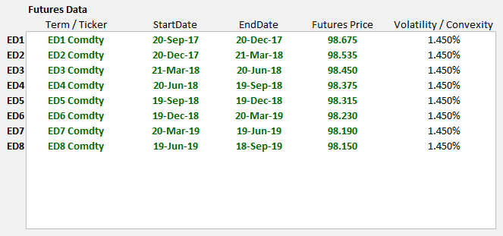

Tenor- & Xccy Basis Curve Settings

isFwdBasis TRUE, FALSE
Specified as part of the curve build properties, this flag controls if Tenor Basis instruments are forward starting. When set to TRUE we must include three additional columns of data within the tenor basis spread table to specify: i) isDateFormat (Boolean) ii) the start date or tenor iii) the end date or tenor for each basis quote as shown in figure 2 below.
Figure 2: Tenor Basis Spread Calibration Data Input
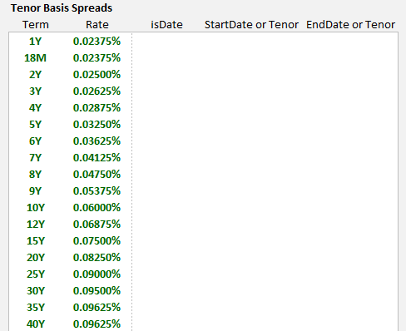
isFwdInter TRUE, FALSE
This parameter is specified within the basis conventions and is used for both Tenor and Xccy Basis curves. Post calibration STD Swap curves store a table of discount factor and forward rate results. Setting this parameter to TRUE interpolates swap curves by forwards using equation (36) below and FALSE will interpolate by discount factors using equation (33).
Within basis curves this flag can only be set to true when the dependency curve is a swap curve. An error will be returned if this flag is set to true and the dependency curve is a basis curve. We should also specify the interpolation method when setting isFwdInter = TRUE using the ‘fwdInterpolation’ flag. The choice of fwdInterpolation must match the interpolation method set in the swap curve for calibration consistency.
We recommend building swap curves using Linear-Spline interpolation and specifying basis curves with isFwdInter set to TRUE and fwdInterpolation set to use Linear-Spline interpolation.
On calibration node points both the Libor forward rate and discount factor tables are synchronized. We summarize these calculations below and highlight that interpolated points can have different values and can cause pricing differences.
The forward / discount factor relationship is summarized mathematically as
$DF\left(t,T\right)≝\frac{1}{1+f*(T-t)}$ (33)
we also know that
$DF\left(t,S\right)*DF\left(S,T\right)=DF\left(t,T\right)$ (34)
combining the above gives
$\frac{1}{1+f*(T-S)}= DF\left(S,T\right)=\frac{DF(t,S)}{DF(t,T)}$ (35)
leading to
$f=\left(\frac{DF(t,T)}{DF(t,S)}-1\right)*\left(\frac{1}{(T-S)}\right)$ (36)
where t<S<T

FixingSource CurveCollection name or ‘ITSELF’ keyword
The fixing source parameter is part of the basis curve build properties. Traditionally all cash fixings are specified as part of the STD swap curve. A fixing table will only be sourced from swap curves when the market id or static data table name set using the ‘STD’ keyword. Furthermore basis curves only calibrate using a cash Libor fixing if the ‘SpotRateTerm’ field is specified, see below.
Additionally basis curves can specify their own Libor fixings if the FixingSource parameter is set using the ITSELF keyword. The fixing source can also point to a STD swap curve in a different curve collection, which is quite useful for curves such as JPY TIBOR where the basis is a spread to JSCC LIBOR but the fixings need to come from a JPY TIBOR curve.

OptimizePerformance TRUE, FALSE
Controls the Newton-Raphson calibration precision and exit criteria. Used within the swaps conventions section, TRUE optimizes for performance and exits the solver once a single instrument calibrates within precision tolerance, which is acceptable with high precision tolerance. FALSE ensures that all instruments calibrate within tolerance. The default value is FALSE.

SpotRateTerm 1M, 3M, 6M, 12M
This parameter is set within the tenor basis conventions input block and specifies which fixing to use from the STD swap curve fixing table. The swap curve containing the fixing data must specify and the STD keyword as its MarketID or StaticDataTable name. Omitting this field will result in no cash Libor fixing being used in basis curve calibration.

FX Forward Curve Settings
The FX Forward curve solves for any CSA discount curve using a combination of standard OIS and Xccy curves. MLIB implies the collateralized discount curve using the FX Forward invariance relationship such as that in (37) solving for the one unknown term.
For example to solve for a discount curve, such as GBP_EURCSA i.e. a GBP discount factor adjusted for EUR collateral posting, we have the following FX Forward relationship
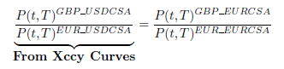 (37)
re-arranging this gives 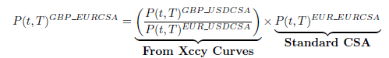 (38)
In MLIB we represent (37) as
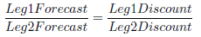 (39)
and likewise (38) is represented as
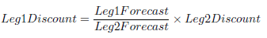 (40)

In MLIB we set-up the FX Forward Curve to represent equation (40) as shown in table 2.
Table 2: FX Forward Constant Settings for GBP_EURCSA
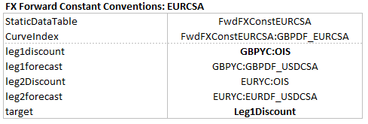
However it is perhaps easier to consider the settings in table 2 as a representation of equation (39), where the target parameter specifies what we are solving for. In this case we solve for the Leg1 discount factor i.e. GBPDF_EURCSA and therefore the leg1 discount term specified i.e. GBPYC:OIS is treated as the initial guess for the analytics solver.
Please note that if we invert equation (39) we achieve the same results, since this mathematically equivalent.

or log of spreads added on top of the base curve
Note that inverting this expression yields the same result.

